Project Design Phase-I
Solution Architecture

Date | 19 September 2026
Team ID | PNT2022TMIDxxxxxx
Project Name | EV Market Performance & Insights
Maximum Marks | 4 Marks

Solution Architecture:
Solution architecture is a complex process – with many sub-processes – that bridges the gap between business problems and technology solutions. Its goals are to:
- Find the best tech solution to solve existing business problems.
- Describe the structure, characteristics, behavior, and other aspects of the software to project stakeholders.
- Define features, development phases, and solution requirements.
- Provide specifications according to which the solution is defined, managed, and delivered.

Sample Solution Architecture Diagram:
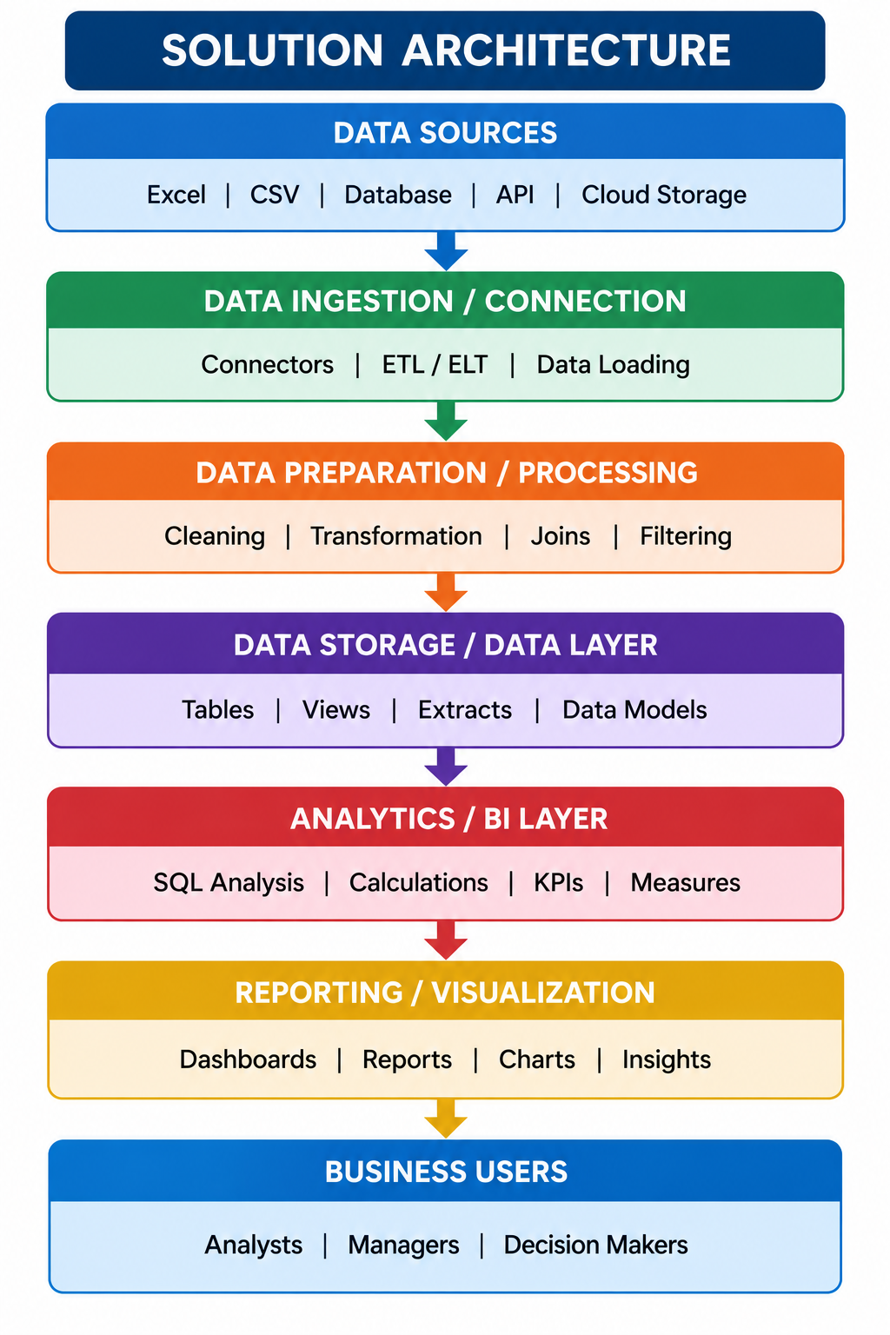

Component Description Table
Component Name | Description / Role in Architecture | Technology Used

Proposed Architecture Diagram – EV Market Performance & Insights
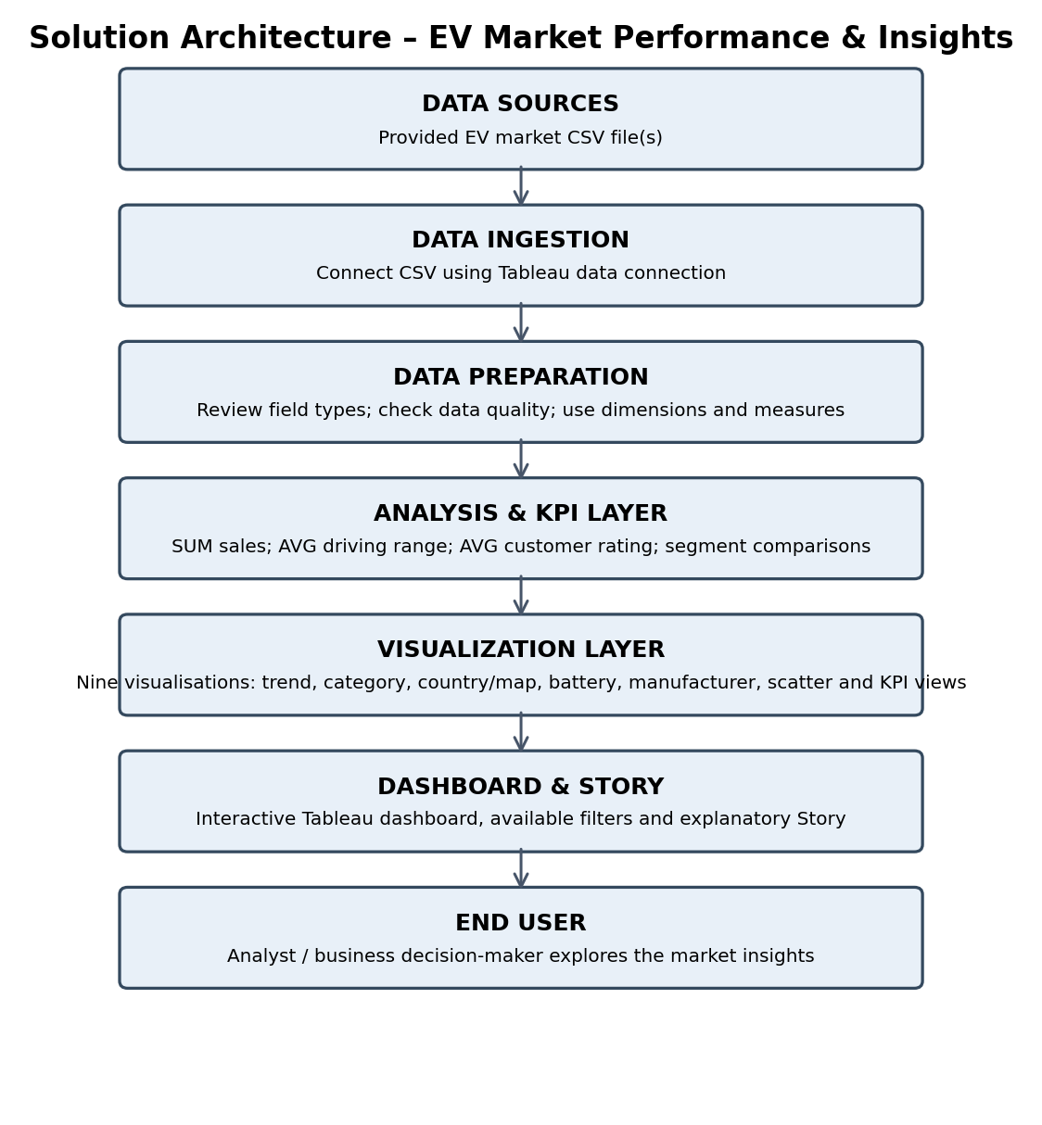
Component Description Table – Project Implementation
Component Name | Description / Role in Architecture | Technology Used
Data Source | Contains the EV market records used for analysis, including year, country, manufacturer, vehicle category, battery technology, sales, range, rating and price. | Provided EV market CSV file(s)
Data Connection & Preparation | Connects the CSV source to Tableau and makes the fields available as dimensions and measures for analysis. | Tableau Public Desktop – CSV/Text File connection
Analysis & KPI Calculations | Aggregates sales and calculates average driving range and customer rating; supports comparisons across years and market segments. | Tableau measures, aggregations and calculated fields where required
Visualization & Dashboard | Displays KPI cards and the nine dashboard visualisations in a consolidated view with available filters. | Tableau worksheets and dashboard
Story & Publishing | Presents key findings in a sequence and makes the completed analysis accessible online. | Tableau Story and Tableau Public

